2018 | 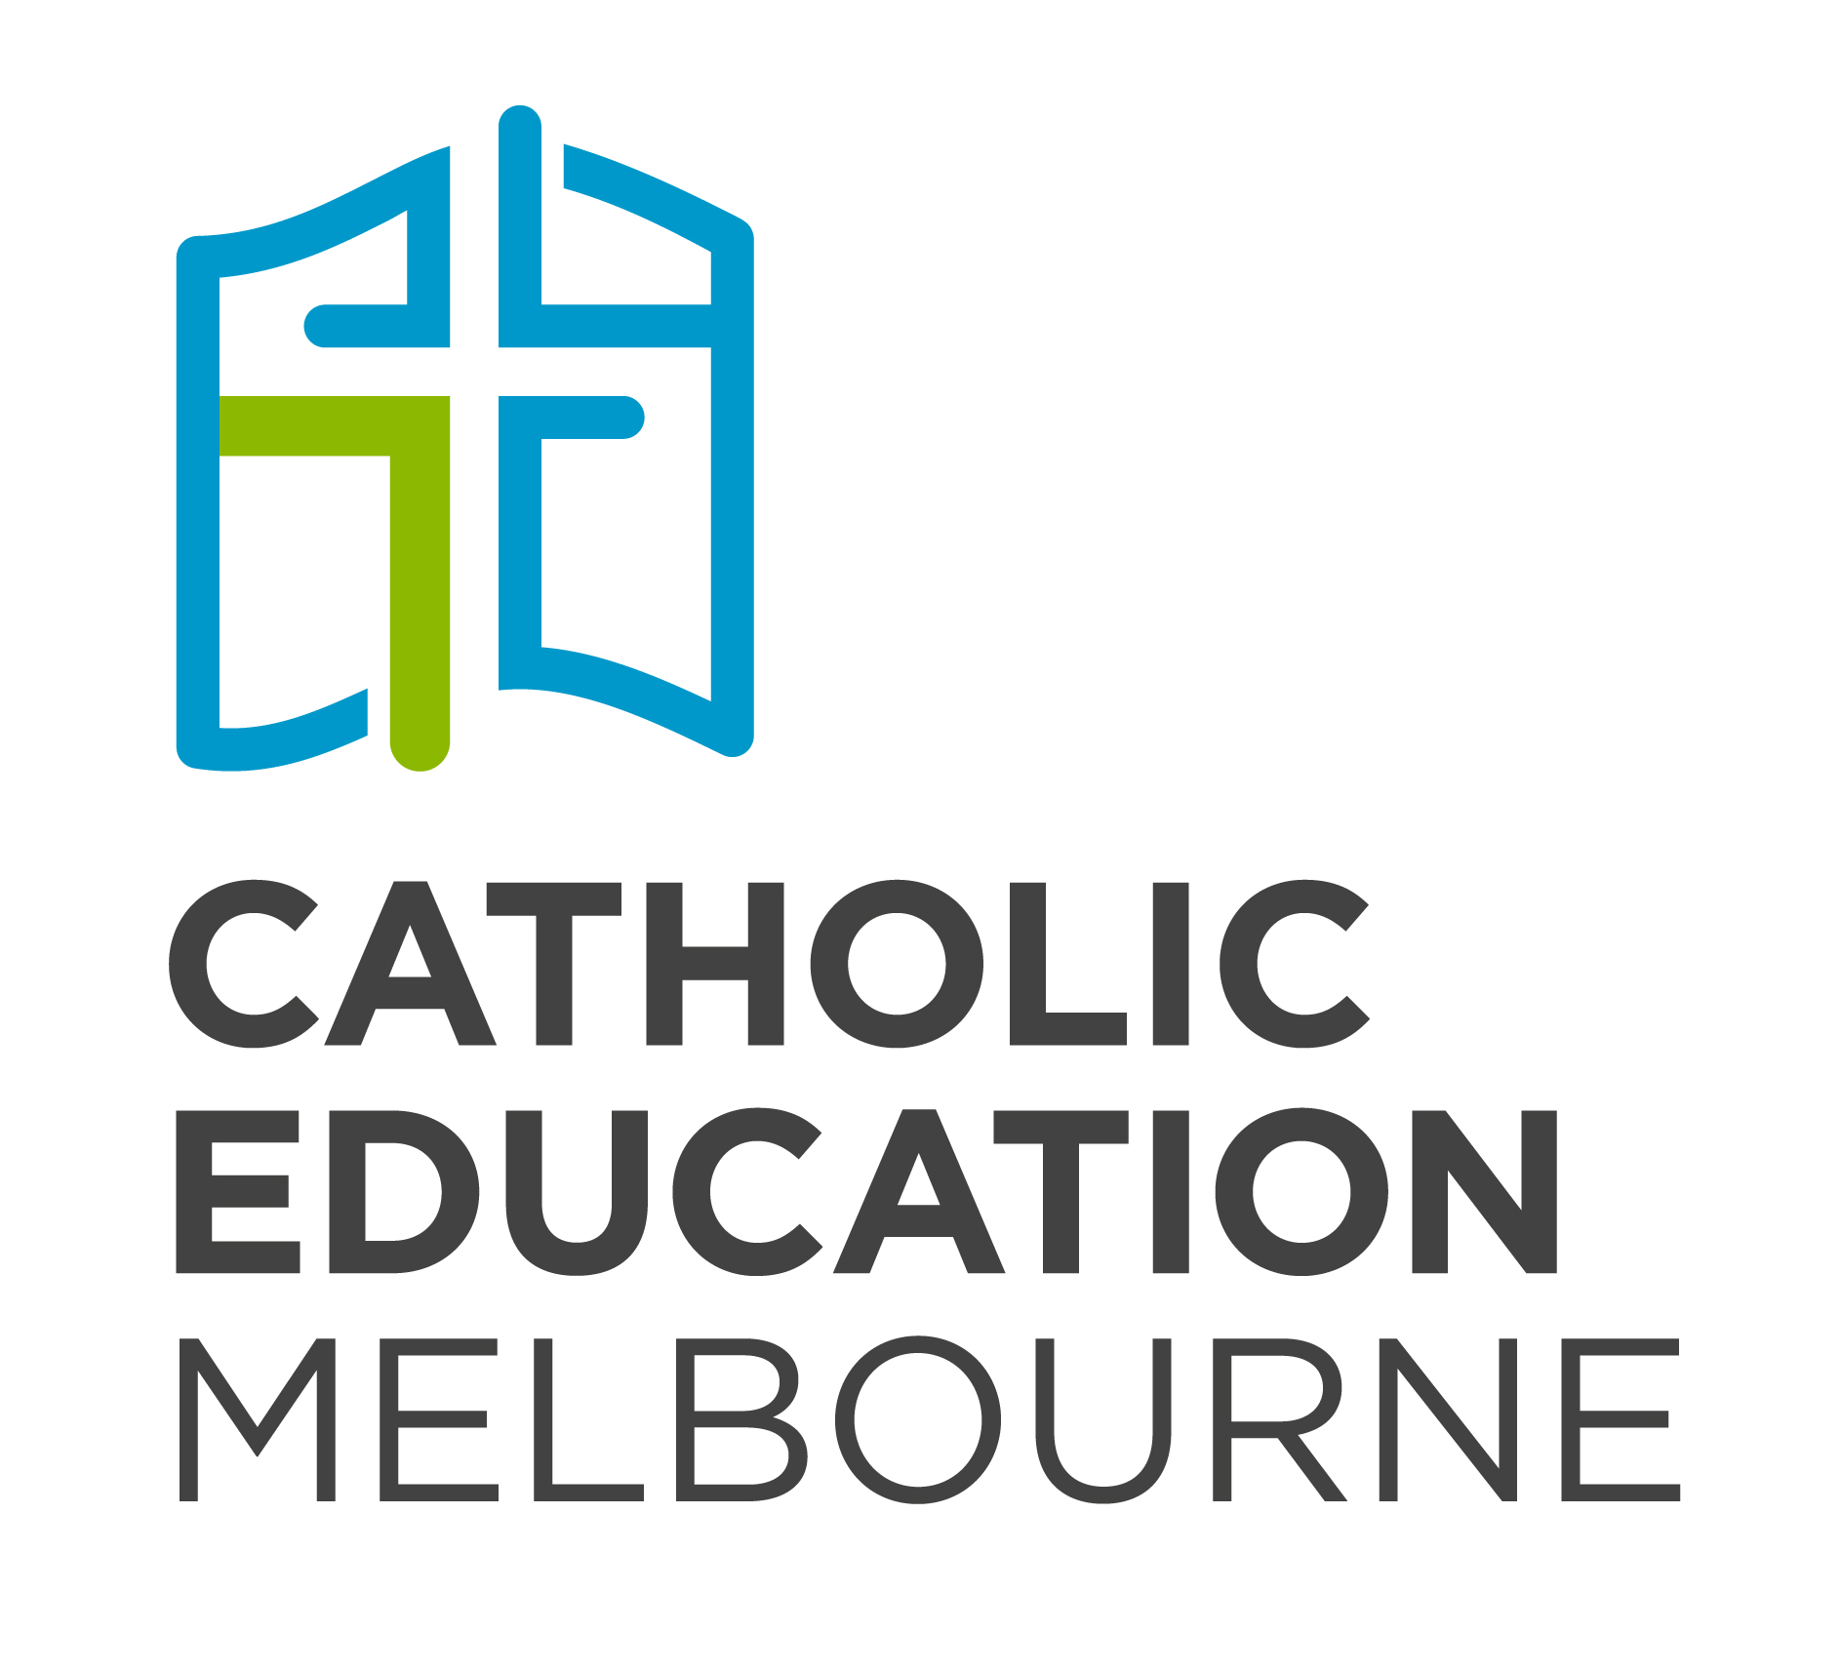
Liturgical Calendar for Schools
Liturgical Year B – The Year of Mark  Weekday Readings Year II  Year of Youth | Liturgical Dates from Liturgy Brisbane  Calendar from the Australian Catholic Bishops Conference website  Special Community Occasions from OurCommunity.com.au  Global Social Justice dates from Caritas Australia  HOW TO READ  Solemnities  Liturgical Memorials and Feast Days  School Dates & Public Holidays  Cultural Memorials

Term 1 Monday 29 January – Thursday 29 March. Students return: Tuesday 30 January. *Easter 30 March –2 April
Week | Sunday | Gospel | Liturgical Memorials and Special Dates
1 | 28 January  4th Sunday in Ordinary Time  green | Mark 1: 21–28  Jesus commands an unclean spirit. | Tue 30 Jan  31 Jan  2 Feb  2 Feb  Feb (1st Wk) | Students return to school  Memorial of St John Bosco  Solemnity of the Presentation of the Lord  World Wetlands Day  World Interfaith Harmony Week
2 | 4 FEBRUARY  5th Sunday in Ordinary Time  green | Mark 1: 29–39  Jesus heals Simon's mother-in-law. | 5 Feb  6 Feb  8 Feb  10 Feb | Memorial of St Agatha  Memorial of St Paul Miki and his Companions  International Day of Prayer and Awareness Against Human Trafficking (Memorial of St Josephine Bakhita)  Memorial of St Scholastica
3 | 11 February  6th Sunday in Ordinary Time  World Day of Prayer for the Sick  green | Mark 1: 40–45  Jesus cures a leper | 13 Feb  Wed 14 Feb | Anniversary of Apology to Australia’s Indigenous People  Ash Wednesday
4 | 18 February  1st Sunday of Lent  Project Compassion  violet | Mark 1: 12–15  After forty days in the desert, Jesus proclaims the reign of God. | 20 Feb  21 Feb  22 Feb  23 Feb | World Day of Social Justice (cf. 23 September: Social Justice Sunday)  International Mother Language Day  Feast of the Chair of St Peter, Apostle  Memorial of St Polycarp
5 | 25 February  2nd Sunday of Lent  violet | Mark 9: 2–10  Jesus is transfigured before Peter, James and John. | 2 Mar  2 Mar | World Day of Prayer  Schools’ Clean Up Day
6 | 4 MARCH  3rd Sunday of Lent  violet | John 2: 13–25  Jesus drives the money-changers from the Temple. | 8 Mar | International Women’s Day
7 | 11 MARCH  4th Sunday of Lent  violet or rose | John 3: 14–21  Jesus converses with Nicodemus. | 11–18 Mar  12 Mar  16 Mar  17 Mar | Catholic Education Week  Labour Day Holiday  National Day of Action Against Bullying and Violence Solemnity of St Patrick

Term 1 (continued)
Week | Sunday |  |  | Gospel |  | Liturgical Memorials and Special Dates
8 |  | 18 MARCH  5th Sunday of Lent  violet |  | John 12: 20–33  Jesus foretells of his death and resurrection. |  | 17–25 Mar  19 Mar  21 Mar  22 Mar |  | Cultural Diversity Week  Solemnity of St Joseph, Spouse of the Blessed Virgin Mary  Harmony Day  World Water Day
9 |  | 25 MARCH  Passion (Palm) Sunday  red |  | Mark 14: 1 – 15: 47  The Passion.
The Easter Triduum
School Holidays |  |  | 29 MARCH  Thursday of the Lord’s Supper  white |  | John 13: 1–15  Jesus washes the feet of his disciples.
 |  |  | 30 MARCH  Friday of the Passion of the Lord  red |  | John 18: 1 – 19: 42  He had always loved those who were his in the world, but now he showed how perfect his love was.
 |  |  | 31 MARCH  The Easter Vigil in the Holy Night  white |  | Mark 16: 1–7  Jesus of Nazareth, who was crucified, has risen.
 |  |  | 1 APRIL  Easter Sunday  white |  | John 20: 1–9  The teaching of Scripture is that he must rise from the dead.
School Holidays |  |  | 8 APRIL  2nd Sunday of Easter (Divine Mercy) |  |  |  | 8 April  9 Apr  11 Apr |  | Orthodox Easter  Solemnity of the Annunciation of the Lord  Memorial of St Stanislaw
Term 2 Monday 16 April – Friday 29 June
Week |  |  | Sunday |  | Gospel |  | Liturgical Memorials and Special Dates
1 |  |  | 15 April  3rd Sunday of Easter  white |  | Luke 24: 35–48  Jesus appears to the disciples gathered together. |  | 13–22 Apr |  | Victorian Youth Week
2 |  |  | 22 April  4th Sunday of Easter  World Day of Prayer for Vocations  white |  | John 10: 11–18  The Good Shepherd. |  | 25 Apr  26 Apr  28 Apr |  | ANZAC Day  Feast of St Mark the Evangelist  Memorial of St Peter Chanel
3 |  |  | 29 April  5th Sunday of Easter  white |  | John 15: 1–8  Jesus the vine, the Father, the vine-grower. |  | 2 May  3 May |  | Memorial of St Athanasius  Feast of Ss Philip and James, Apostles
4 |  |  | 6 MAY  6th Sunday of Easter  World Communications Day  white |  | John 15: 9–17  Live on in Christ.
5 |  |  | 13 MAY  Solemnity of The Ascension of the Lord  Week of Prayer for Christian Unity  white |  | Mark 16: 15–20  Jesus commissions the eleven, ascends to heaven. |  | 13–20 May  13 May  14–20 May  14 May  15 May |  | Week of Prayer for Christian Unity  Mothers’ Day  CatholicCare Family Week (National Families Week)  Feast of St Matthias, Apostles  International Day of Families
6 |  |  | 20 MAY  Pentecost Sunday  red |  | John 20: 46–23  The Spirit will guide the Apostles to all truth. |  | 22 May  24 May  26 May  26 May |  | International Day of Biological Diversity  Solemnity of Our Lady, Help of Christians  National Sorry Day  Memorial of St Philip Neri
7 |  |  | 27 MAY  Solemnity of The Most Holy Trinity  white |  | Matthew 28: 16–20  Jesus sends forth the Apostles with the promise to be with them always. |  | 27 May –  3 Jun  31 May  1 Jun |  | National Reconciliation Week  Week of Prayer for Christian Unity  Feast of the Visitation of the Blessed Virgin Mary  Memorial of St Justin

Term 2 (continued)
Week | Sunday | Gospel | Liturgical Memorials and Special Dates
8 | 3 JUNE  Solemnity of the Most Holy Body and Blood of Christ (Corpus Christi)  white | Mark 14: 12–16, 22–26  Jesus took bread, broke it and shared it. | 5 Jun  5 Jun  8 Jun  9 Jun  11 Jun | World Environment Day  Memorial of St Boniface  Solemnity of the Most Sacred Heart of Jesus  Memorial of the Immaculate Heart of Mary  Memorial of St Barnabas
9 | 10 June  10th Sunday in Ordinary Time  green | Mark 3: 20–35  Those who do the will of God are family to Jesus. | 11 Jun  13 Jun | Queen’s Birthday  Memorial of St Anthony of Padua
10 | 17 June  11th Sunday in Ordinary Time  green | Mark 4: 26–34  Parable of the mustard seed. | 17–23 Jun  20 Jun  21 Jun  22 Jun | Refugee Week (cf. Migrant and Refugee Week, 20–26 Aug)  World Refugee Day (cf. Sunday 26 August)  Memorial of St Aloysius Gonzaga  Memorial of Ss John Fisher & Thomas More
11 | 24 June  The Nativity of Saint John the Baptist  white | Luke 1: 57–66, 80  Elizabeth gives birth to John. | 28 Jun  29 Jun | Memorial of St Irenaeus  Solemnity of Ss Peter and Paul
School Holidays | 1 JuLY  13th Sunday in Ordinary Time  Aboriginal and Torres Strait Islander Sunday  green | Mark 5: 21–43  Jesus heals Jairus' daughter. | 3 Jul | Memorial of St Thomas, Apostle
School Holidays | 8 July  14th Sunday in Ordinary Time  Apostleship of the Sea  green | Mark 5: 21–43  No prophet gains honour in his native place. | 8–15 Jul  11 Jul | NAIDOC Week  Memorial of St Benedict

Term 3 Monday 16 July – Friday 21 September
Week | Sunday | Gospel |  | Liturgical Memorials and Special Dates
1 | 15 July  15th Sunday in Ordinary Time  green | Mark 6: 7–13  Jesus sends the Twelve out in pairs.
2 | 22 July  16th Sunday in Ordinary Time  Bible Sunday  green | Mark 6: 30–34  Jesus pities the crowd, sheep without a shepherd. |  | 25 Jul  26 Jul | Feast of St James  Memorial of Ss Joachim & Anne (parents of Mary)
3 | 29 July  17th Sunday in Ordinary Time  green | John 6: 1–15  Jesus feeds five thousand. |  | 30 Jul  31 Jul  1 Aug  3 Aug  4 Aug | International Day of Friendship  Memorial of St Ignatius of Loyola  Memorial of St Alphonsus Liguori  Memorial of St Dominic  Memorial of St John Vianney
4 | 5 aUGUST  18th Sunday in Ordinary Time  green | John 6: 24–35  Jesus is the bread of life. |  | 6–13 Aug  6 Aug  6 Aug  8 Aug  9 Aug  10 Aug  11 Aug | National Vocation Awareness Week  Solemnity of the Transfiguration of the Lord  Hiroshima Day  Solemnity of St Mary of the Cross (MacKillop)  International Day of the World’s Indigenous Peoples  Feast of St Lawrence  Memorial of St Clare
5 | 12 August  19th Sunday in Ordinary Time  green | John 6: 41–51  Jesus is the living bread. |  | 12 Aug  14 Aug  15 Aug | UN International Youth Day  Memorial of St Maximilian Kolbe  Solemnity of the Assumption of the Blessed Virgin Mary  (Holy Day of Obligation)
6 | 19 August  20th Sunday in Ordinary Time  green | John 6: 51–58  Whoever eats and drinks of the body and blood of Christ has eternal life. | 18–24 Aug  19 Aug  20 Aug  20–26 Aug  21 Aug  22 Aug  24 Aug |  | Children’s Book Week  World Humanitarian Day  Memorial of St Bernard  Migrant and Refugee Week  Memorial of St Pius X  Memorial of Our Lady, Mother and Queen  Feast of St Bartholomew, Apostle

Term 3 (continued)
Week | Sunday | Gospel | Liturgical Memorials and Special Dates
7 | 26 August  21st Sunday in Ordinary Time  World Day of Migrants and Refugees  green | John 6: 60–69  Many disciples desert Jesus. | 27 Aug  28 Aug  29 Aug  1 Sep | Memorial of St Monica  Memorial of St Augustine  Memorial of the Passion of St John the Baptist  World Day of Prayer for the Care of Creation
8 | 2 september  22nd Sunday in Ordinary Time  green | Mark 7: 1–8, 14–15, 21–23  Jesus confronts the Pharisees, who pay only lip service to God. | September  2 Sep  2–8 Sep  3 Sep  8 Sep  8 Sep | Month of Prayer for the Care of Creation  Fathers’ Day  National Child Protection Week  Memorial of St Gregory the Great  Feast of the Nativity of the Blessed Virgin Mary  International Literacy Day
9 | 9 SEPTEMBER  23rd Sunday in Ordinary Time  Child Protection Sunday  green | Mark 7: 31–37  Jesus heals the deaf man. | 13 Sep  14 Sep  15 Sep | Memorial of St John Chrysostom  Feast of the Exaltation of the Holy Cross  Memorial of Our Lady of Sorrows
10 | 16 September  24th Sunday in Ordinary Time  green | Mark 8: 27–35  A follower of Christ must take up the cross. | 20 Sep  21 Sep  21 Sep | Memorial of Ss Andrew Kim Taegŏn and Paul Chŏng Hasang  Feast of St Matthew, Evangelist  UN International Day of Peace
School Holidays | 23 September  25th Sunday in Ordinary Time  Social Justice Sunday  green | Mark 9: 30–37  Jesus teaches that to rank first, disciples must serve all. | 27 Sep  28 Sep  29 Sep | Memorial of St Vincent de Paul  Grand Final Day Holiday  Feast of Ss Michael, Gabriel and Raphael
School Holidays | 30 September  26th Sunday in Ordinary Time  green | Mark 9: 38–43, 45, 47–48  If they are not against us, they are for us. | October  1 Oct  2 Oct  4 Oct | World Mission Month  Memorial of St Thérèse of Lisieux  Memorial of the Holy Guardian Angels  Memorial of St Francis of Assisi

Term 4 Monday 8 October – Friday 21 December
Week | Sunday | Gospel | Liturgical Memorials and Special Dates
1 | 7 October  27th Sunday in Ordinary Time  green | Mark 10: 2–16  ‘Let the children come to me.’ | 10 Oct | World Mental Health Day
2 | 14 October  28th Sunday in Ordinary Time  green | Mark 10: 17–30  A man asks Jesus what he has to do to enter the kingdom. | 14–20 Oct  15 Oct  17 Oct  17 Oct  18 Oct | Anti-Poverty Week  Memorial of St Teresa of Avila  International Day for the Eradication of Poverty  Memorial of St Ignatius of Antioch  Feast of St Luke, Evangelist
3 | 21 October  29th Sunday in Ordinary Time  World Mission Day  green | Mark 10: 35–45  Whoever aspires to greatness must serve the rest. | 24 Oct  26 Oct  26 Oct | Universal Children’s Day  World Teachers Day (in Australia)  Day for Daniel
4 | 28 October  30th Sunday in Ordinary Time  green | Mark 10: 46–52  Jesus gives sight to Bartimaeus. | 1 Nov  2 Nov | Solemnity of All Saints  Memorial of All Souls: Commemoration of all the Faithful Departed
5 | 4 november  31st Sunday in Ordinary Time  green | Mark 12: 28–34  The wise scribe asks Jesus which is the greatest commandment. | 6 Nov  9 Nov  10 Nov | Melbourne Cup Day  Memorial of the Dedication of the Lateran Basilica  Memorial of St Leo the Great
6 | 11 November  32nd Sunday in Ordinary Time  Remembrance Day  green | Mark 12: 38–44  The widow's mite. | 12 Nov  17 Nov | Memorial of St Josaphat  Memorial of St Elizabeth of Hungary
7 | 18 November  33rd Sunday in Ordinary Time  World Day of the Poor  green | Mark 13: 24–32  Watch for the signs of the coming of the kingdom. | 21 Nov  22 Nov  24 Nov | Memorial of the Presentation of the Blessed Virgin Mary  Memorial of St Cecilia  Memorial of Saint Andrew Dũng-Lac and Companions

Term 4 (continued)
Week | Sunday | Gospel | Liturgical Memorials and Special Dates
8 | 25 November  Solemnity of Our Lord Jesus Christ, King of the Universe  white | John 18: 33–37  Pilate questions Jesus about his identity. | 25 Nov  30 Nov | Year of Youth ends  Feast of St Andrew, Apostle
9 | 2 DECember  (LITURGICAL YEAR B BEGINS)  1st Sunday of Advent  violet | Luke 21: 25–28, 34–36  Be ready for the second coming. | 3 Dec  3 Dec  7 Dec  8 Dec | International Day of People with Disability  Memorial of St Francis Xavier  Memorial of St Ambrose  Solemnity of the Immaculate Conception of the Blessed Virgin Mary
10 | 9 December  2nd Sunday of Advent  violet | Luke 3: 1–6  John the Baptist proclaims a baptism of repentance. | 10 Dec  13 Dec  14 Dec | UN International Human Rights Day  Memorial of St Lucy  Memorial of St John of the Cross
11 | 16 December  3rd Sunday of Advent  violet or rose | Luke 3: 10–18  John announces the coming of the Messiah. | 18 Dec | International Migrants Day (cf. World Day of Migrants and Refugees)
School Holidays | 23 December  4th Sunday of Advent  violet | Luke 1: 39–45  Mary visits Elizabeth. | 24 Dec  25 Dec  26 Dec  26 Dec  27 Dec  28 Dec | Christmas Eve  The Nativity of the Lord (Christmas Day)  Feast of St Stephen  Boxing Day  Feast of St John, Apostle and Evangelist  Memorial of the Holy Innocents
School Holidays | 30 December  Feast of the Holy Family of Jesus, Mary and Joseph  white | Luke 2: 41–52  Jesus is found in the Temple.

